**Rough level design and ideas- maybe a few diagrams of example levels? Can we have a simple tutorial level design?**

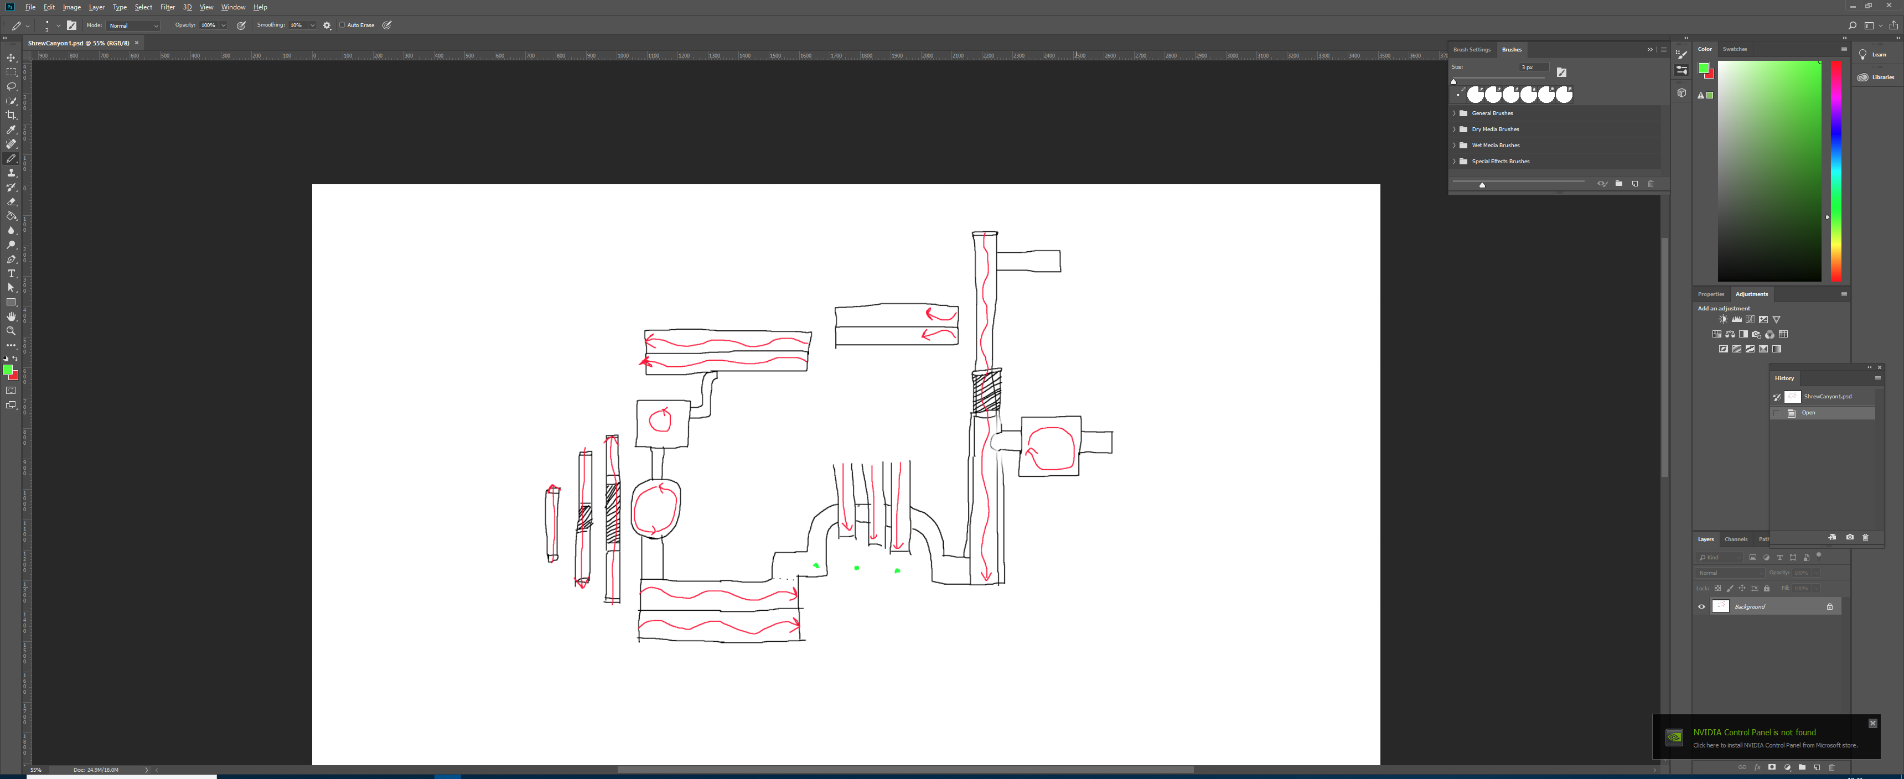

A basic sketch of the level, featuring basic geometry and enemy paths. The level revolves around the shrew caravan.

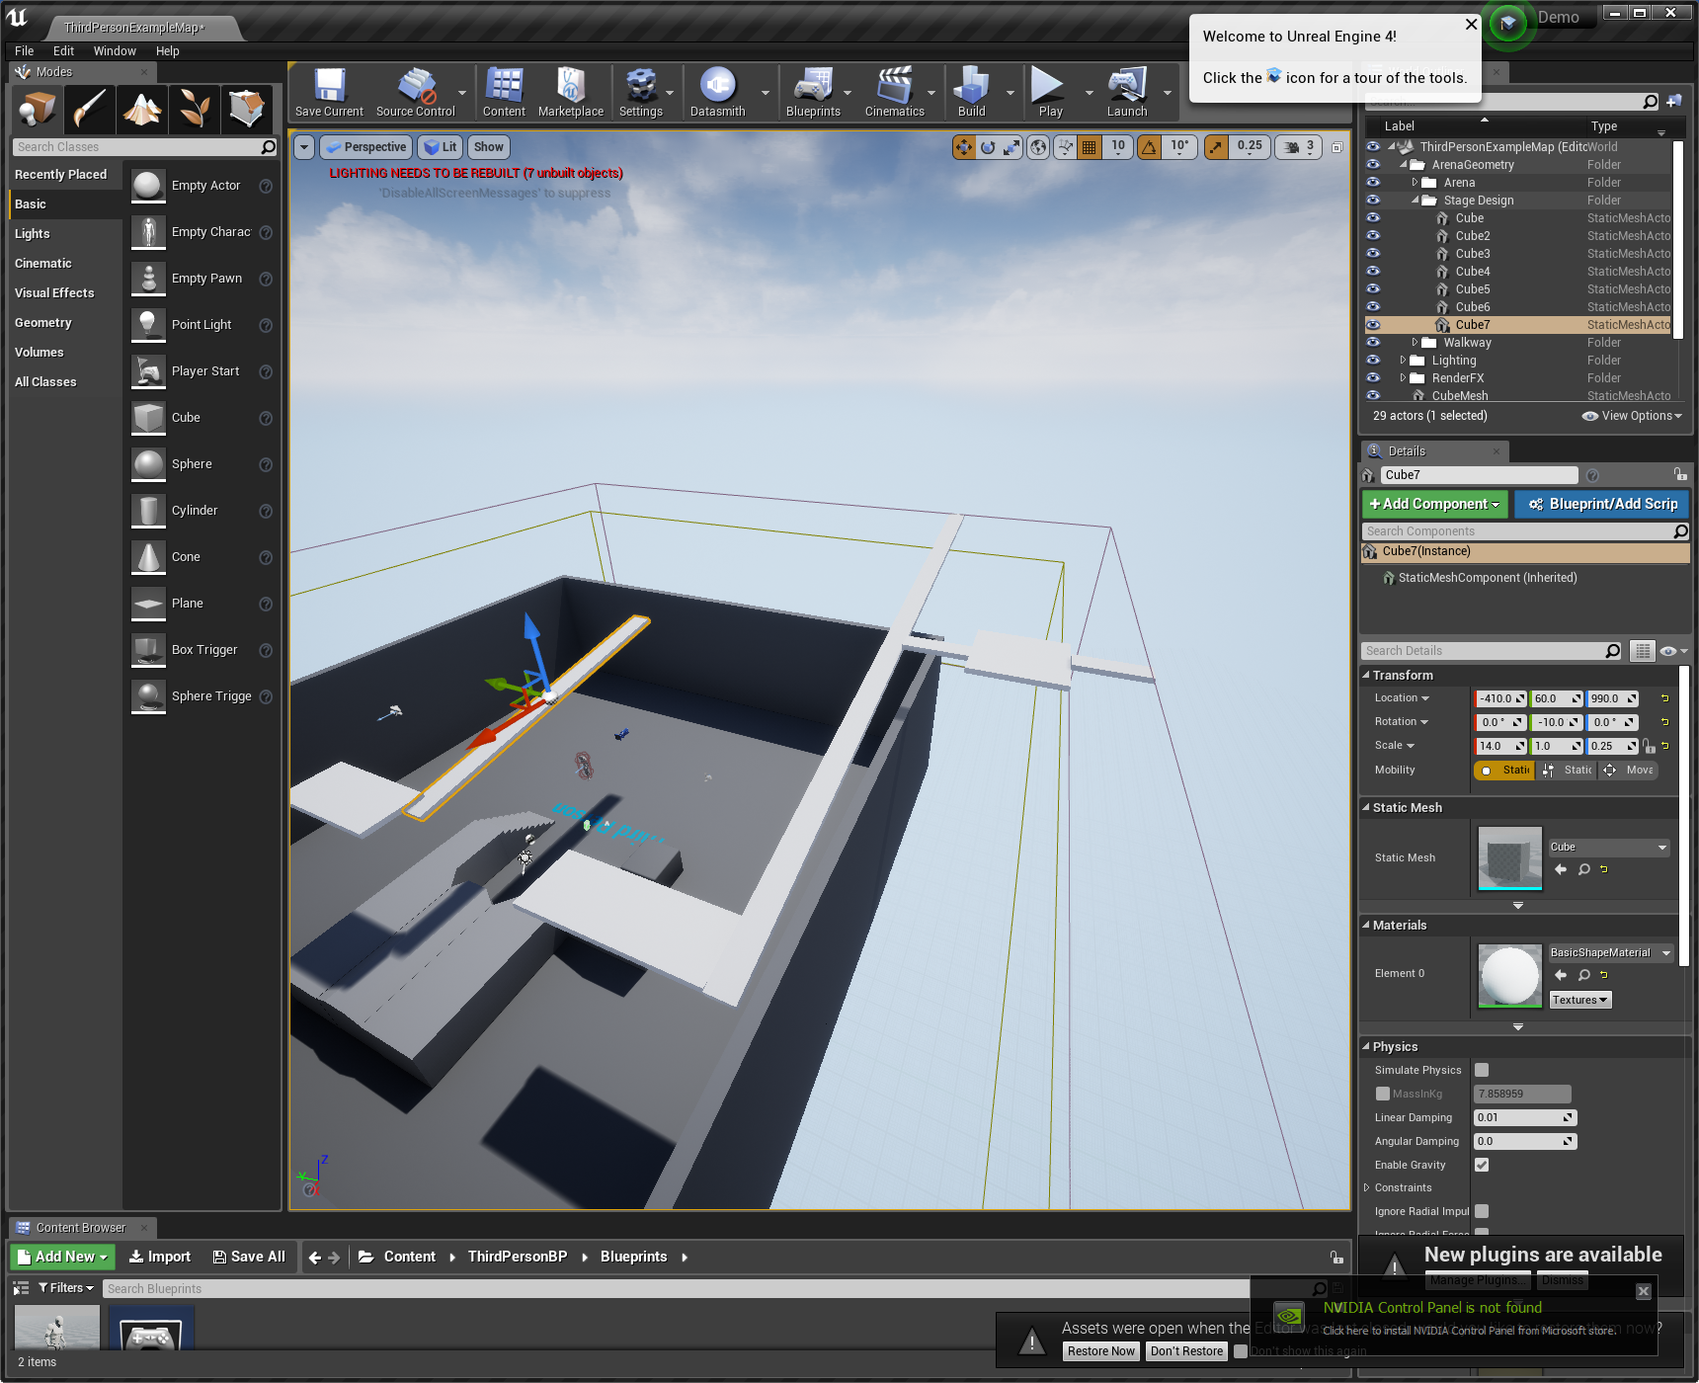

White-box creation.

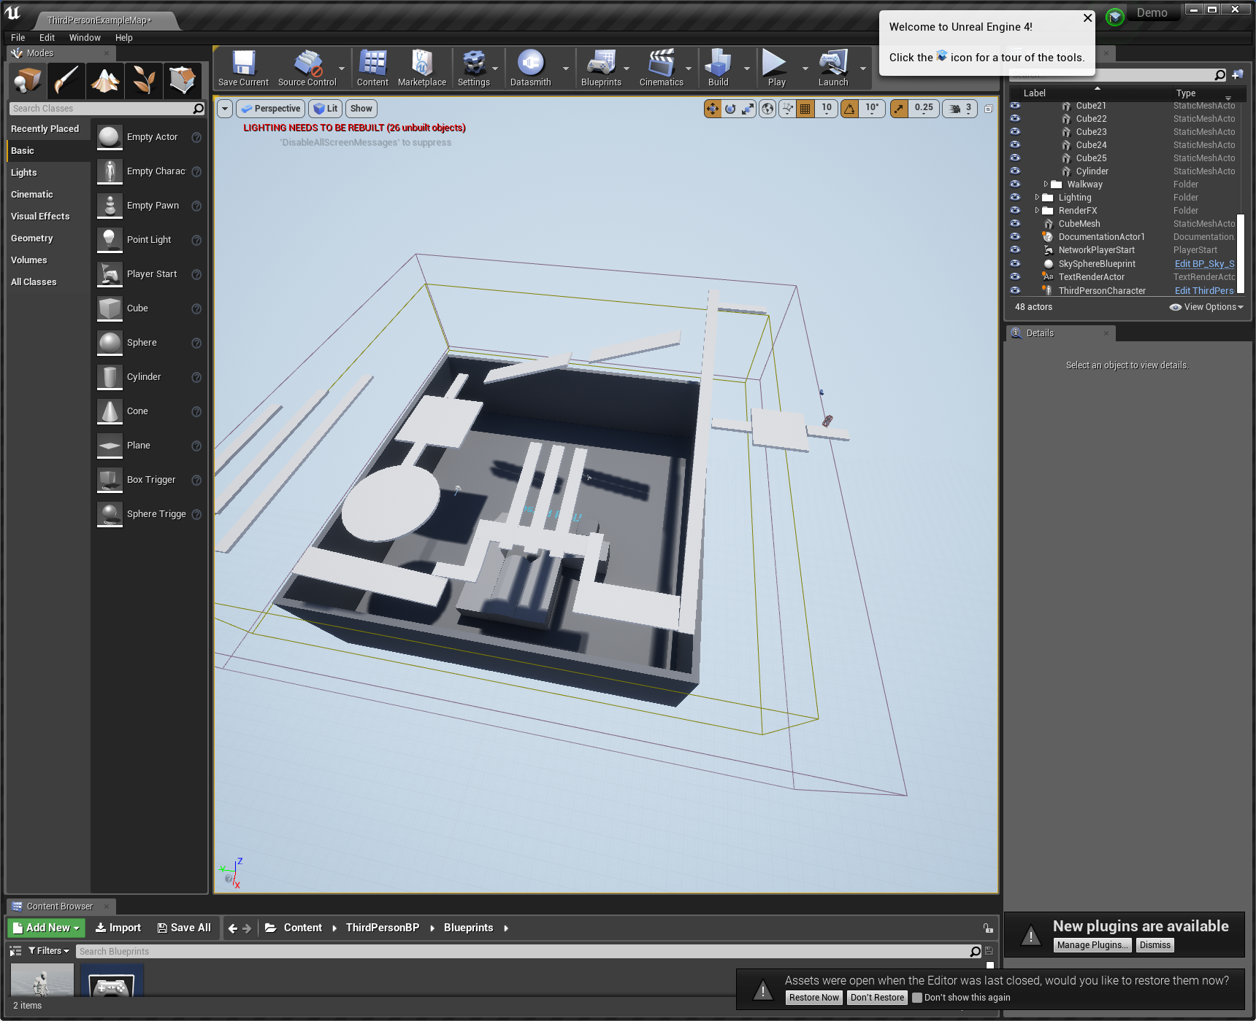

Level Layout finished.

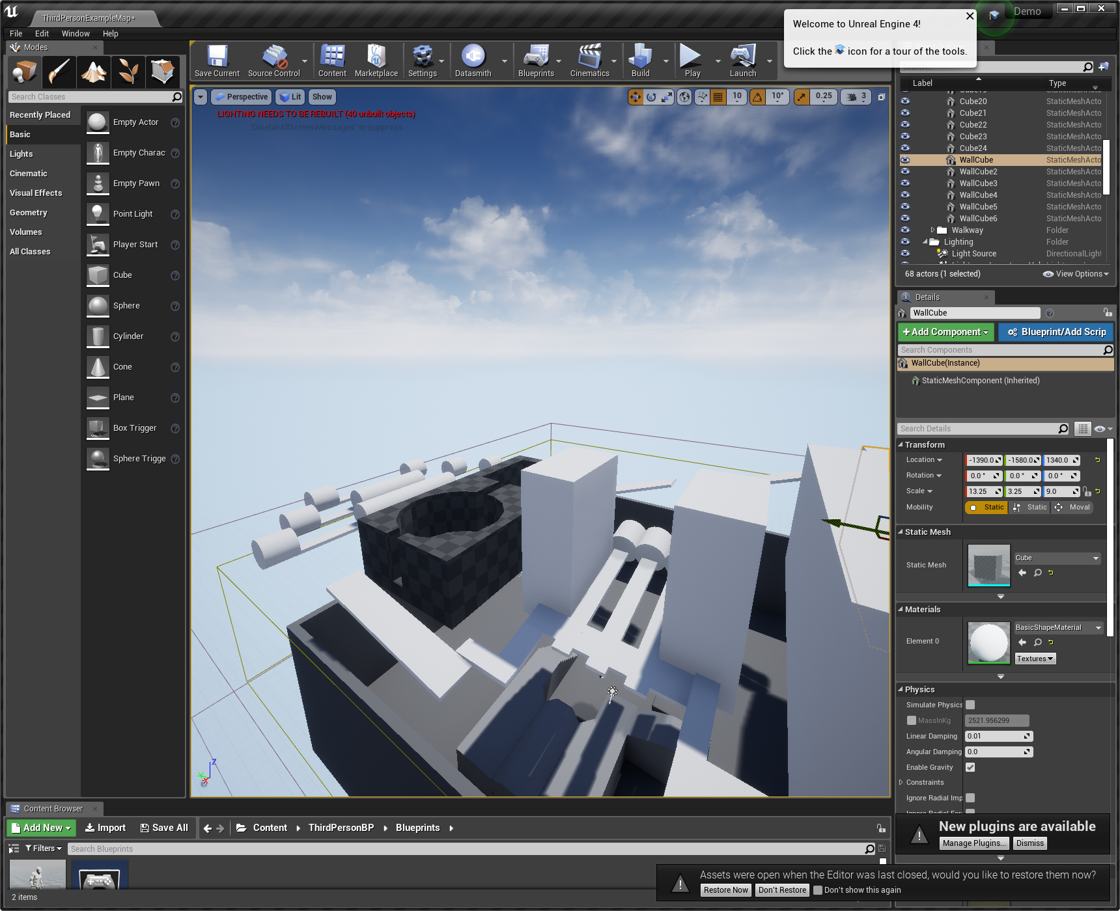

Adding walls. Walls could very easily block the camera, so we need to be careful.